**When arranging your mid year outing to the shore, ensure you consider sea shore wellbeing as a component of your readiness, particularly in the event that you aren't acquainted with the sea shore you're heading out to.**

**Here's our rundown of sea shore security tips:**



* **Slather on the sunscreen – Nothing ruins a sea shore trip quicker than a burn from the sun on the very first moment. Ensure you get the chance to appreciate the sun each day of your excursion by covering yourself and the children in a liberal covering of high SPF sunblock. Also, reapply after lunch – particularly on the off chance that you've been swimming**
* **Ensure your feet - A long stroll on the sea shore is an incredible method to go through a marvelous sentimental night. In any case, unpleasant and rough coastline can unleash ruin on your exposed feet. A simple sea shore wellbeing arrangement is to pack a couple of reef shoes for everybody so as to keep cuts and scratches from broken coral, broke glass, sudden tide pools and other sand dangers.**
* **Swimming wellbeing – Spending the day in the surf is a genuine impact! From boogie boarding to swimming, there are such a significant number of approaches to have a great time in the sea.**

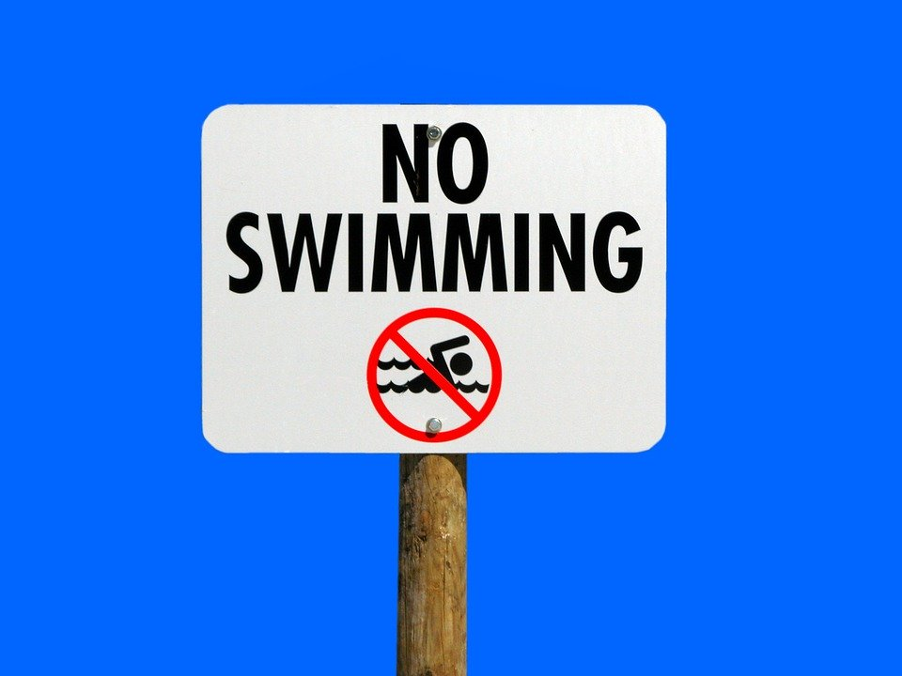

* **Be that as it may, the vast water requires a specific regard. One of the most significant sea shore wellbeing tips is to empower everybody in your gathering to swim with alert. Buoyancy gadgets are not a viable replacement for realizing how to swim – don't get in the sea without exercises. Additionally read:  Save Big with an Off-Season Beach Week .Top U.S.**
* **Sea shores for Your Next Vacation Sea shore security – Are you thinking about whether your piece of sand will incorporate a lifeguard? Before you travel, investigate whether your sea shore trip incorporates the consolation of an ensured lifeguard. The Beach Patrol is prepared to look for and caution beachgoers of riptides and different hazardous swimming conditions just as jellyfish and other stinging animals.**
* **Watch the Climate– When you book your excursion months ahead of time, you may have the unfortunate planning to land on a similar day as a climate catastrophe. With downpour comes storm water overflow that regularly prompts polluted water at the sea shore that you'll need to keep away from. Additionally, look out for high surf warnings.**
* **Most dire outcome imaginable – Although events are phenomenal, you would prefer not to be the person who recognizes what it resembles to manage a jellyfish or stingray assault. Focus on neighborhood news reports and approach surfers and mariners for subtleties on what's hanging tight for you in the water. Nobody needs to think about that a mishap may transpire, yet purchasing travel protection is a shrewd move to be safe. In specific situations, travel protection can give repayment to restorative help or even clearing if your sea shore get-away gets ugly.**



* [**Drink the correct fluids**](https://infotech876.blogspot.com/2019/11/rundown-of-things-to-convey-when-you-go.html)**– Keep everybody hydrated with a lot of water and dodge liquor. Notwithstanding getting hazardously got dried out, drinking liquor at the sea shore can debilitate your judgment exactly when you need it most.**
* **Watch out underneath – Many sea shores that take into account voyagers include bluffs with dazzling vistas. These are lovely spots to watch out from, however they can be hazardous. One wrong step could mean a genuine fall, and falling rock implies being underneath them can be significantly progressively unsafe. Lifeguards caution that "even only a softball-sized shake can be destroying tumbling from a 50-foot precipice."**

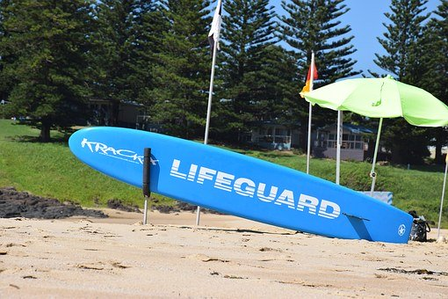

* **Natural life cautioning – While part of the charm of sea swimming is the opportunity to see sea-going creatures in the wild, make sure to stay away.**
* **Viewing an ocean turtle nourishing is a pail list minute – don't destroy it by attempting to contact its shell or upset its daily schedule. Purple or blue banners show jellyfish or different hazardous untamed life. On the off chance that you are stung, visit a lifeguard or look for restorative assistance right away. Riptides are genuine - Hidden perils like harsh surf, undertow and tear flows can rapidly transform an evening paddle into a genuine occurrence. Take a couple of moments to watch a video of a riptide, figure out how to recognize the signs and invigorate the water security aptitudes of any feeble swimmers in your gathering**